GameManager.cs

GridManager.cs

LevelManager.cs

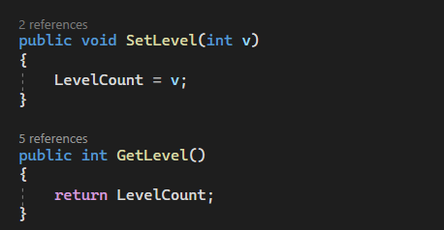

Tile.cs

PlayerManager.cs

EnemyManager.cs

Player.cs

Enemy.cs

CloseInvestMarket.cs

ClosePlayerStats.cs

DungeonTraderGlobalVar.cs

ExitButtonScript.cs

InvestmentMarketScripts.cs

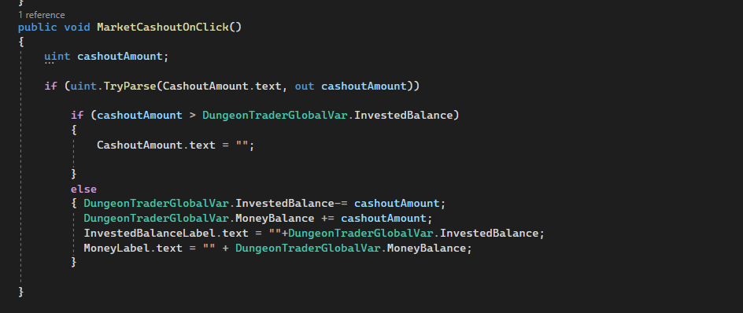

InvestOpenButtons.cs

MenuButtonScripts.cs

OpenShopTest.cs

ShopCloseButton.cs

ShopScripts.cs

StartButtonScript.cs

StatsOpenButton.cs

Scena in unity:

Jocul pornit in Unity:

Meniul:

Jocul:

Magazinul:

Jocul cu tot GUI-ul:

